Temperature Sensor | Integration Overview
The integration of the DS18B20 temperature sensor into our cloud computing architecture ensures accurate and reliable temperature monitoring, complementing the environmental data collected by the MQ-135 smoke sensor. Initially, we tested the setup using simulated data before deploying real DS18B20 sensors with ESP8266 microcontrollers in the final implementation phase. The DS18B20 was chosen for its high accuracy, waterproof capability, and digital communication via the OneWire protocol, making it ideal for IoT-based environmental monitoring. Sensor data is transmitted via MQTT to the cloud platform, where it is processed and visualized in Node-RED. Additionally, a bi-color LED indicator was implemented to provide real-time visual alerts—green indicating safe temperature levels and red signaling high-temperature conditions that may require attention.
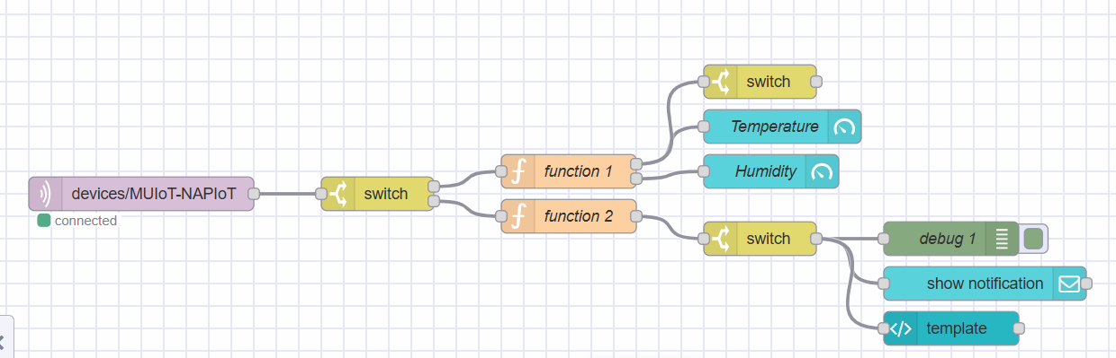

Data Processing and Visualization
Once the system transitions from simulated to real environments using ESP8266, the setup will maintain the integrity of data transmission using MQTT to Node-RED, where data processing and decision-making processes occur. The ESP8266 will be responsible for reading sensor outputs, converting them into a format suitable for analysis, and publishing them to the designated MQTT topics. Node-RED, configured on FlowFuse, will then subscribe to these topics, process the incoming data, and dynamically update the dashboard to reflect real-time environmental conditions. This real-time visualization is crucial for immediate response to potential hazards and long-term environmental monitoring, ensuring that data-driven insights are accessible through a user-friendly interface on the dashboard, enhancing operational efficiency and safety.
